Content

Inverse heat transfer software 1

Why Python? 1

Architecture 3

Programming concepts worth pointing out 11

Interesting bugs worth pointing out 12

GUI choice 12

GUI creation 13

Computation engine description 15

Basic flow of the software 22

Dependences and libraries 22

User guide for the software 24

Possible features and improvements 25

Parameters inputted from user 26

PARAMETERS TESTING 28

Methodology of the tests: 29

Results of the parameter testing: 30

TODOS AND IDEAS 37

# Inverse heat transfer software

* This document is a draft of the diploma thesis describing the nuts and bolts of the software solution
* **Please excuse the lack of structure here for the time being**

# Why Python?

* Because it is extremely easy to use and has capabilities in all **three programming paradigms** that we need for this project
  + **Scientific computation**
    - As the main core of the project is its computation engine for simulating heat transfer, we need a tool that supports useful data structures (e.g. matrixes) and numerical methods to quickly work with them (e.g. interpolation or linear equations solver).
    - Through the libraries like numpy or scipy (described later), python can gain scientific and numeric capabilities matching or even exceeding other scientific software like Matlab. And opposed to Matlab, it can be used freely without any license.
    - Not only can we run scientific computation, but also the displaying of data in form of graphs can be done easily with libraries like matplotlib.
    - All three abovementioned libraries are often used together in what is known as SciPy stack.
    - Because of the abundance of these libraries, one can even choose from multiple similar implementations of the same functionality, which adds a benefit of being able to experiment with various approaches – that leads to deeper understanding of the subject.
  + **GUI creation**
    - Python offers multiple libraries for creating GUIs, the basic one called Tkinter is even in its standard library.
    - It has a connection with the well-known Qt platform (through PyQt5 library), which is a complete solution for creating even more advanced GUIs.
  + **General control flow**
    - To allow for good user experience, computation engine and GUI need to be connected into one piece, and this is done by defining custom application logic.
    - This is probably the area where python shines the most – the ease with which the main logic of the program can be written, thanks to its easy syntax and high readability.
* In general, it can be said that python was chosen because of its easy syntax and the high number of available libraries, that exist for almost any possible use case
* <https://www.python.org/>
* Possible alternatives to python
  + C++
    - Description
      * Lower level language, that is known for its high speed, but also for its complex code.
    - Advantages
      * Generally, code runs much faster than in python, as the C++ code is being compiled into the machine code, which can run directly on the hardware.
        + Python, on the other hand, is interpreted language, which means it is not compiled into machine code. It allows for the python code to be run almost anywhere. The cost of this is the inferior speed of execution.
        + Also, for the language to be compiled, it needs to be statically typed (the variables cannot change their type – string, integer… - during the runtime), whereas interpreted languages can be dynamically typed (variables can change their type). Being dynamically typed allows for higher freedom, but slows down the execution speed, as the interpreter always needs to check the data type of the used variables – as opposed to statically typed languages, where the compilation makes sure the variables stay the same type, and can therefore optimize operations on those variables.
    - Disadvantages
      * Writing usable code in C++ takes much longer than in python, as there are much more syntax rules which to abide by, and the standard functionality of the language (standard library) is far from being so broad as in python, so one needs to write custom code even for operations that are already “built-in” in python itself. (Python is sometimes called a “battery-included language”.)
      * Also, more experience in programming is needed to use C++, because of the higher complexity it requires (programmer is in charge of memory management etc.).
    - *“Python is much more beginner-friendly, while C++ is a more complicated, low-level language. C++ has more syntax rules and other programming conventions, while Python aims to imitate the regular English language.”*
    - <https://www.bitdegree.org/tutorials/python-vs-c-plus-plus/>
    - *"Python where we can, C++ where we must"*
    - <https://stackoverflow.com/questions/2560310/heavy-usage-of-python-at-google/2561008#2561008>
  + Matlab/Octave
    - Description
      * Computation software for scientists and engineers
    - Advantages
      * Everything in Matlab is designed to work together easily, which is more robust and less prone to unexpected changes that in case of bundling together multiple libraries in python.
      * It comes with the full GUI (development environment) that is simplifying the process of developing and debugging.
        + However, there is a similar IDE included in Anaconda python distribution, called Spyder, which was designed specifically to resemble Matlab environment (having a console, showing all variables, history of commands etc.).
      * All the functionality in Matlab is arguably more rigorously tested and validated by the industry than python libraries (which are open source on the other hand, so really anybody can verify their correctness).
    - Disadvantages
      * Matlab requires a rather expensive license to be used for commercial purposes. Octave is for free, but it is lacking some features from Matlab and is generally running much slower.
      * Toolboxes to extend Matlab functionality (can be thought of as additional libraries) are also not for free
      * Matlab itself and all the toolboxes are closed source and developed and maintained by a single company (Mathworks), which makes it a single point of failure – as opposed to the true open-source philosophy of python and its libraries.
    - <https://realpython.com/matlab-vs-python/>
    - <https://www.mathworks.com/products/matlab/matlab-vs-python.html>

# Architecture

* **Computing engine solving the heat transfer equations**
  + One for classical problems, one for inverse problems
  + Helper module for interpolation
    - Turns out to be much quicker than the classical scipy interpolation (scipy.interpolate).
    - Reason being the specific way we need the interpolated values – all the time we need to interpolate a value on the exact same place in the array.
    - The class in the module is being initialised by an array of values x (in ascending order) and a specific value x0 (or a list of them), which marks the place(s) of our interest.
    - It will determine the exact position of the x0 value in the x array.
    - When supplied an array of y values, having the same dimension as the x array it was initialised with, it will return the y0 value that is on the exact same spot in the y array as the x0 value in regard to the x array (which equals to the interpolated value).
    - At first, we had individual classes for handling the interpolation of a single value and for interpolating a list of values
      * This had a small but measurable speed improvement, as the interpolating function did not have to spend time on checking this difference during the execution, thus saving time
      * However, instantiating of the custom class was unnecessary polluting the code, so we moved that deciding logic to the interpolation module itself, using the factory design pattern
        + <https://en.wikipedia.org/wiki/Factory_method_pattern>
* **GUI with integrated graph, menu options and simulation controllers**
  + **Qt5 Designer**
    - .ui file will be created, which contains the information about the UI. It can then be transformed into a python file or be just imported and parsed as is.
    - During the development it is easier to use the .ui file, but before the final release it is beneficial to transform it to its own python file
      * Reason being that when converting application to .exe file, all the non-python files must be then present in the same directory as the .exe file for the imports to work. When creating a python file from it, it will be imported in the main module and will not have to be present after the conversion.
  + **Graphs for both temperature and heat flux displaying**
    - They are created as individual modules (classes), to increase the possible customization of both plots.
  + **User input generators**
    - It is very modular, code does not have to be changed (open for extension, closed for modification) – infrastructure in place
      * Adding a new customized input field into the GUI is a matter of creating a new record in a dedicated file (heat_transfer_user_inputs_classic.py)
      * We can easily specify the name of input element to target it, and also the variable name the value will be then assigned to – so we can use it further downstream and send it wherever we want (to the computation engine in this case)
    - All the units are well documented
    - It offers an easy possibility of declaring default values, so that user does not have to input everything from scratch before every simulation.
    - It allows for custom description of each parameter, so user can have better idea what that parameter means – this description will be available in GUI after hovering over the parameter label.
    - There is an input validation in place, so when the field is expecting a whole number, inputting a decimal number or some letters will cause the validation to fail. In that case the wrong value will be replaced with a default value and user will be notified.
    - Little challenge was not to confuse users nor computation engine with units (on small objects it is beneficial to measure distance in centimetres, however the computation engine is expecting everything to be in SI units – metres)
      * It was handled by a “multiplicate_to_SI” coefficient, which is a part of each user input row, and is responsible for transforming values visible by user (centimetres) to SI values (metres). In this case the coefficient has a value of 0.01, as a length in centimetres must be multiplied by this number to yield a length in metres.
    - **Possible improvements**:
      * Transferring the information to a JSON file, and just load it on __init__ - this way the user input would be completely separated from the code (as we would not be touching the .py code file, but rather a JSON data file, which could add a little comfort in the way we are not afraid of mistakes there “because it is not the code”, and can be more user friendly)
  + **GUI features**:
    - Information panel for the user on the top
    - Highlighting the button that was clicked to give a visible feedback
    - Locking the inputs when simulation is running, not to confuse user
    - Hovering over input variable shows its description
    - Possibility of saving the data and/or plots from the simulation
* **Multithreaded infrastructure for the GUI**
  + Workers, that enable using more threads and sending signals between those threads (on progress (time), finish (error margin) etc.)
  + They are enabled by PyQt5 library, which supports this multithreaded behaviour very well, in contrast to Tkinter, which did not have this capability (and had to be hacked around to produce a working solution)
  + Creating GUI applications is little bit different from other application’s development and has its own specific hurdles. One of the problems is the unresponsiveness (freezing) of the GUI when some background tasks is going on (like a heat transfer simulation in our case).
  + The GUI is normally running only on one thread (synchronously), and when this thread is busy with simulation, it cannot respond to user actions (events) in the GUI itself. This is not only user non-friendly but causes the whole application to be impossible to be controlled (by buttons etc.) – the only way then is to wait until the simulation finishes.
  + Another way to look at things is that the one GUI thread is running in an infinite loop, listening for events. When user clicks a button or does some other interaction with a GUI, an event is registered, and some action is being executed. However, until this event is satisfied (the action is complete), the GUI cannot process any other events (resulting from user action) – and the application looks unresponsive or even crashes. In our case user would be able to start the simulation by clicking a “run” button, but after that all the clicks would be suppressed until the simulation would be over.
  + If we want to “do more things at once” (run some calculations on the background, and still listen for the user input, that is possibly influencing those background processes), we need to incorporate second thread, whose only purpose would be to run background processes. The main GUI thread’s only responsibility would be to listen for user-based events (mouse clicks), and transmitting the commands to the “background thread,” which is doing the heavy lifting of calculating the simulation and rendering the results.
  + Tkinter, our first choice as a GUI framework, is single threaded only, it has no capabilities whatsoever for multiple threads to operate at the same time. However, there is a possible solution how to overcome this problem (be it a little bit hacky). Tkinter has a method called after(timestep, function), which allows for a certain function to be called in regular timesteps from the main GUI thread.
    - We took advantage of this to call small pieces of simulation between handing the focus to the GUI to listen for the user input. It meant that the main (and only) GUI thread was constantly switching between simulation mode and listening mode (with the listening period lasting couple milliseconds).
    - This solution fulfilled the desired result (being able to both run calculations and listen for user input at the same time) but was far from being perfect. One of the disadvantages of this solution is that the calculation was being constantly interrupted by the listening periods, which caused the time for the whole calculation to be higher than without those listening “pauses”. Also, there was a need to cut simulation into a lot of smaller pieces, as the simulation cannot run constantly because of those interruptions. These pieces cannot be very big, because they themselves could cause the application to be unresponsive or “laggy,” when being in the middle of simulating this big chunk. These pieces also should not be very small, because of the pausing time, which would cause the application to spend more time in listening mode than in calculating mode, which would slow things down immensely.
  + After contemplating all the Tkinter disadvantages, we decided to replace it with PyQt5, which natively supports multithreaded behaviour.
    - PyQt5 provides an easy way how to handle multithreading with its own classes (QRunnable and QThreadPool). This way it is trivial to define a function that should run on the background and can be spawned and controlled by user interaction in the GUI. It also makes it easy to retrieve information from the background thread, that can emit data which will be picked up by the main thread.
    - Data from the background thread can be emitted on different occasions.
      * By emitting positive values after each step in a calculation, we make sure that the timer in the GUI is being incremented (it is a sign of the calculation running).
      * After the calculation thread finishes, it emits two values. First is the message that it has finished, so we can reflect the state in GUI and save the resulting graphs, if wanted. Second message caries over the result of the calculation in the form of the error margin – this will be displayed in GUI afterwards, to be visible for the user.
    - However, it is not enough to have a one-directional connection from the calculation thread to the main GUI thread – we also need a communication channel in the opposite direction, to be able to control the calculation (to pause it, stop it etc.).
    - Specifically for the purpose of multithreaded communication, python standard library offers a module named queue (<https://docs.python.org/3/library/queue.html>), which we took advantage of. Queue is a data structure that allows for the communication between two software components (like threads). Both components can insert information onto the queue (put() method), or retrieve the information from there (get() method).
    - We set up a shared queue between main GUI thread and calculation thread, so that the main thread can send commands via this queue, and calculation thread is listening for these commands. These commands are in the form of words like “pause”, “stop” or “continue” – to which the calculation thread is reacting accordingly.
    - After we had a working bidirectional connection between the main GUI thread and the calculation thread, the last problem had to be solved – how to best update the plots in GUI, so that the user can see the simulation in real time.
      * There were multiple possible ways of achieving this (make it either a responsibility of the main GUI thread, the calculation thread, or even create a brand-new thread just for the purpose of plotting the results).
      * In the end, we decided to give this job to the calculation thread, so the main GUI thread can be as responsive as possible for the user and incorporating a new thread could be unnecessarily complicating the whole architecture.
      * It certainly has a drawback of slowing the simulation down, because calculation thread must also update the plot, but is arguably the most concise and least difficult to implement solution.
        + In the case of speed problems, the dedicated thread for graph plotting would come into play. However, the speed improvements are hard to predict, as there would be extra communication overhead of the calculation thread sending the calculated data frequently to the plotting thread, probably through the shared queue.
      * Plotting the results from the calculation thread is done by passing it a reference of a GUI plot, whose plot() method will be called with the data from the calculating thread – effectively updating the plot.
  + Apart from multithreaded solution, there is also a multiprocessed solution
    - Multithreaded solution is generally easier and quicker to setup, it has the benefits of shared memory, but in python only one thread can be really executing the code at the same time – meaning the speed improvement does not have to be so huge as with multiprocessed solution (GIL problem - <https://realpython.com/python-gil/>).
      * One nice thing about multithreading is that there does not have to be only one other thread, but depending on the computer processor, there can be multiple of them. And even when there are no available threads at the moment, the function to execute will be queued, and as soon as one thread is available, it will start with the execution.
    - Multiprocessing generally takes longer time to implement and instantiate, has some additional memory overhead, and communication between processes is not very smooth. However, once it is running, it can really run in parallel with the main process, without any GIL issues.
  + <https://en.wikipedia.org/wiki/Multithreading_(computer_architecture)>
  + <https://en.wikipedia.org/wiki/Thread_(computing)>
  + <https://www.learnpyqt.com/courses/concurrent-execution/multithreading-pyqt-applications-qthreadpool/>- the code was taken from this source and then modified for our needs
  + <https://stackoverflow.com/questions/29158220/tkinter-understanding-mainloop> - description of Tkinter problems
* **Material service**
  + Is responsible for supplying material data to the GUI. From these data the material choice dropdown menu is created in GUI – all materials defined in our database will be displayed there. The material properties will be loaded into the local memory, ready to be queried, when user chooses the material for the simulation.
  + We created our own database of material properties, as there seems to be no python module that would satisfy our need.
    - There is a library <https://pypi.org/project/materials/> , but it only includes very limited choice of materials, which is not suitable for us.
  + Our material database exists in the form of CSV file with material properties – **metals_properties.csv**.
  + It was generated by **fetch_elements.py** script, which is taking material data from Wikipedia
    - Script is visiting the Wikipedia page of all metals and takes the properties we need for the simulations - rho, cp and lambda.
    - Material data can be refreshed anytime just by running this script.
    - It uses the fact, that Wikipedia has almost static and non-changing structure of the webpage, and so the information there can be easily identified through web scraping (<https://en.wikipedia.org/wiki/Web_scraping>).
* **CSV file with data from measurements – DATA.csv**
  + It contains comma-separated rows with measurement data regarding:
    - Time from the beginning of measurement [seconds]
    - Temperature measured inside the body [Celsius]
    - Heat flux applied to the body [Watt]
    - Ambient Temperature in the room [Celsius]
  + There is a standalone module, **experiment_data_handler.py**, that is processing the data in a .csv file, and transforming them into a python data structures (lists of values) inside its own class
* **Performance tester**
  + <https://www.youtube.com/watch?v=8qEnExGLZfY>
  + <https://osf.io/upav8/>
  + <https://www.youtube.com/watch?v=YjHsOrOOSuI>
  + <https://hackernoon.com/the-rules-of-optimization-why-so-many-performance-efforts-fail-cf06aad89099>
    - - 3 rules of optimization:
    - 1. Don't
    - 2. Don't ... yet
    - - finish your code (having even some comparison of performance)
    - - have tests
    - - now
    - 3. Profile
    - - there is no way we can correctly judge where the most time is spent,
    - so better use profilers
  + One of our goals was to optimize the code for the computing engine as much as possible, so the calculations and therefore the whole simulation would be as quick as possible (without sacrificing any precision).
  + This process was a gradual one – we started with a code that was written intuitively, so that it is logically performing all the calculations step by step, and we can be confident (in a certain manner) that nothing has been forgotten or missed.
  + This initial implementation laid down the foundation – we knew how quick our engine is, and what precision it can achieve. All further improvements had one goal – increase the speed without worsening the precision (quality of the result).
    - Without this first and “non-optimized” implementation it would be harder to make further improvements, as we would have no comparison according the quality of the result.
  + After creating a reference implementation, we already had some idea which parts could be rewritten, omitted or transferred to make the code run faster. However, before making any changes, there is a need to note down what performance we have at the moment – making a profiling of the code.
    - This profiling has also the goal of uncovering which exact parts of the code are taking the most time to perform. The optimization should then try to eliminate these bottlenecks first, before focusing on other parts that are not so crucial.
  + Developing a performance profile of our computation engine showed, without a surprise, that by far the most time is spent in the function **evaluate_one_step ()**, which is responsible for the actual calculation of temperature distribution in the object.
    - The most crucial part of this function, that we simply cannot omit – the solving of a linear equation (A*T=b) – was initially taking only around 15 % of the overall function. Meaning that whole 85 % of the function was spent by just preparing the variables for the linear equation.
    - Our goal from this moment was to ensure that most of the time will be spent by solving the system of linear equations – meaning getting rid of as much other stuff as possible.
    - Optimization would go on gradually, and the steps we were taking were as follows:
      * refactor the way the parameters A and b are being created
      * factor out some calculations that were the same for every step (moving them out of the function not to calculate them every time, and letting them be instance variables)
      * creating our own interpolation engine, that is optimized for our purpose
  + After the final step of the optimization, the percentage of linear equation solving in the evaluate_one_step() function rose up to 80 % - meaning more than **5-fold improvement** in the speed of the whole function, and also the whole simulation.
    - One reminder for the point about the hardware optimizing being generally advised first – running the code on a more powerful computer was able to increase the speed **2,5-fold**, without any struggles with code optimization.
  + TODO: INCLUDE REAL CODE EXAMPLES OF WHAT WAS OPTIMIZED
    - Deep copying is very slow – better to copy arrays with the use of assignment [:]
    - Interpolations.py is a big optimisation by itself
      * Also, the creating of a custom class for float or list to save one if statement during the execution is a nice speed improvement.
  + Numpy arrays are very expensive to modify
    - <https://towardsdatascience.com/hitchhiker-tips-on-effectively-using-python-numpy-arrays-66649b7bd5fb>
    - <https://www.jessicayung.com/numpy-views-vs-copies-avoiding-costly-mistakes/>
    - <https://docs.scipy.org/doc/numpy/user/quickstart.html>
  + The performance profiling was done on two computers with different computational power, which uncovered one point about performance improvements – that generally the better and cheaper option how to make the code run faster is to use better hardware.
    - Reason being the high cost of additional development process (as the development time is quite expensive), and the risk of the optimization breaking something. Usually the optimization also means the code becomes less understandable, making it harder to maintain and enhance in the future, because it was written with only the speed in mind.
    - However, hardware solution can reach its limits quite quickly, when no parallelisation is used. Reason being the speed of CPU is not so drastically different when comparing a “weak” computer and “strong” computer. What differs, is the amount of cores and threads these computers have in store – therefore to really squeeze the most performance out of a powerful computer, some form of parallelisation is needed (meaning running calculations on multiple threads or processes).
  + How to run the line profiling in python
    - <https://github.com/rkern/line_profiler>
    - <https://stackoverflow.com/questions/23885147/how-do-i-use-line-profiler-from-robert-kern>
    - Line profiler we used is not a part of a standard python library, therefore it needs to be installed by a package manager (pip).
      * pip install line_profiler
    - Then we place a decorator (<https://www.geeksforgeeks.org/decorators-in-python/>) "@profile" above the function we want to test.
    - Finally, we run our script.py with following command.
      * kernprof -lv script.py
    - The results will show us how much time in total, and as a percentage, was spent on each line of the script – nicely identifying possible performance bottlenecks.

# Programming concepts worth pointing out

* Creating a class for material, storing the material properties inside.

class Material:

def __init__(self, rho, cp, lmbd):

self.rho = rho # Mass density

self.cp = cp # Specific heat capacity

self.lmbd = lmbd # Heat conductivity

self.Mat = Material(rho, cp, lmbd)

* Creating an interpolation object according to the amount of points we are interested in, to save if statements during the execution.
  + This should be covered by a factory design pattern however
* Communication between threads through the shared queue.
* Not printing so much information to the console.

import random

if random.random() < 0.1:

print("sleep")

* Defining how the class should be displayed when using print() on it through __repr__() magic method.
* Class inheritance between Simulation and InverseSimulation
  + It allows us to use all the code from Simulation class in the InverseSimulation class without need of copying it. We can then extend this behaviour by defining new custom variables and methods on the InverseSimulation class – without affecting the parent Simulation class.
  + We also have the possibility of overriding methods from parent class, by this we can unite the names of public methods for both classes – even the child InverseSimulation class can have its own public evaluate_one_step() method. This way we have a common interface for all the simulations, which results in more readable code (it could be said that both classes implement the same interface).
  + <https://www.thedigitalcatonline.com/blog/2014/05/19/method-overriding-in-python/>
* Version control through git and github
  + Git is a protocol (version control system) and github is a service for hosting git repositories.
  + It is a priceless tool in software development, that makes sharing code between more people much easier than other methods (sending emails, using Google Disk etc.).
  + <https://git-scm.com/>
  + <https://github.com/>
* Usage of pre-commit git hooks to reduce the possibility of committing bugs in the code (rejecting the commit when any of the defined tests fails).
  + <https://githooks.com/>
* Static analysis of the code through mypy
  + Python is by nature interpreted programming language, and so the lines of code are encountered by interpreter only at runtime
  + One of the advantages of it is superior portability of the code, which can be moved easily as a text file, and modified without issues, opposed to compiled languages like Java or C++.
  + Drawbacks of it include the impossibility of discovering obvious bugs prior to runtime (like using undefined variables etc.), which can cause unexpected problems later on (especially when these bugs are hidden outside of the main code execution, which is not being well tested).
  + <https://realpython.com/python-type-checking/>
  + <https://medium.com/@ageitgey/learn-how-to-use-static-type-checking-in-python-3-6-in-10-minutes-12c86d72677b>
  + <https://blogs.dropbox.com/tech/2019/09/our-journey-to-type-checking-4-million-lines-of-python/>

# Interesting bugs worth pointing out

* There can be bugs without programming, but there can be no programming without bugs (own thought).
* <https://softwareengineering.stackexchange.com/questions/195571/is-it-possible-to-reach-absolute-zero-bug-state-for-large-scale-software>
* <https://www.quora.com/Are-there-programmers-who-write-virtually-bug-free-code>
* Users could choke the simulation by clicking PAUSE and STOP button when the simulation was not running, and it caused the RUN button being seemingly unresponsive, because in the shared queue there were multiple commands for the simulation to go to paused or stopped state – therefore preventing the simulation from advancing, until all the non-running commands were exhausted by clicking RUN button multiple times.
* Not being able to finish the simulation because our last time step exceeded the biggest time value of the simulation, so there was no interpolated value of temperatures and heat fluxes.
* Slight differences in Operating Systems between Windows and Linux caused the GUI written for Windows not working in Linux – additional code had to be written there to distinguish between the platforms and call the platform-specific methods.

# GUI choice

* PyQt5 should be replaced in the end by PySide2, because of its better licensing conditions (software using PyQt5 must contribute some money to PyQt5 if being monetized)
  + “*PyQt5 is available under a GPL or commercial license, and PySide2 under a LGPL license.”*
  + *“if you plan to distribute your software commercially you will either need to purchase a commercial license from Riverbank for PyQt5 or use PySide2”*
  + <https://www.learnpyqt.com/blog/pyqt5-vs-pyside2/>
* Tkinter is a basic library for building python GUIs, as it already comes packaged in a standard library, therefore these is no need for installation (<https://docs.python.org/3.8/library/tkinter.html>)
* It is very easy to use, but is not very suitable for bigger applications
* PyQt5 offers multiple benefits over Tkinter
  + Performance:
    - PyQt5 allows for the easy possibility of multithreading, which is making the application quicker and more responsive. There is no need to switch attention between calculating and listening mode as would be necessary in case of Tkinter version.
  + Functionality
    - It has a richer library of available widgets and behaviours that can be easily implemented.
  + UI development
    - PyQt5 offers an app called Qt Designer, which is itself a GUI for creating GUIs. This UI is then completely separated from the business logic, and therefore almost anybody without any programming skills can create it. As long as the names of the widgets remain the same, it is possible to change layout of the UI freely, without having to worry about breaking the code.
    - <https://doc.qt.io/qt-5/qtdesigner-manual.html>
  + Usage outside python
    - Qt as a platform for creating GUIs is not used only in Python, but in a variety of widely used languages and platforms (<https://en.wikipedia.org/wiki/Qt_(software)>).
    - Both the knowledge of it, and the possibility of transforming the app into a different language, if necessary, can prove to be very useful.

# GUI creation

* The basic structure of the GUI is defined by **heat_transfer_gui.ui** file.
  + It is created with the use of Qt Designer application.
  + It offers user friendly creation of GUIs, which do not require almost any programming skills.

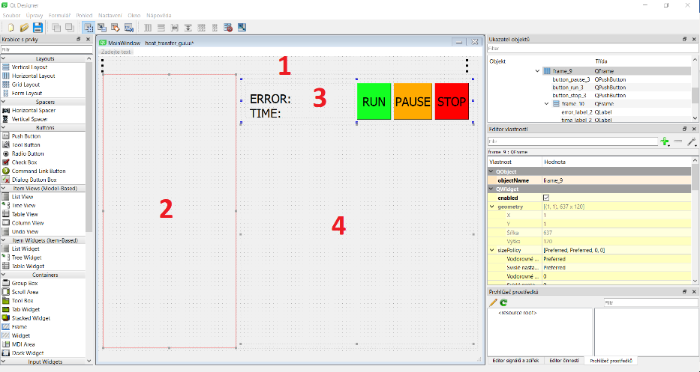

* In the Designer, we create the basic structure of the application – defining the components (smaller windows) on the screen, where data will be rendered afterwards.
  + **(1)** On the very top we create a label that will be used for showing custom information for the user spanning the whole width.
    - It has a fixed height of 30 pixels, and together with the fixed font size of 15 points it means the showed text will be always fully visible.
  + **(2)** The whole left side below is occupied by a vertical layout in which all the user inputs and options will be rendered.
    - It has a maximum width of 400 pixels, so it is not increasing unnecessarily at the cost of the graphs.
  + **(3)** The upper right side is dedicated for the control and information panel
    - It has a fixed height of120 pixels, so it is not increasing unnecessarily on at cost of the graphs.
    - It hosts three buttons for controlling the simulation and two labels for getting information about the simulation.
  + **(4)** The biggest area on the screen is there to accommodate graphs of temperature and heat flux progress.
    - This vertical layout can increase as much as possible on the screen, to offer good visibility for both graphs.
* In **heat_transfer_gui.py**, we are building on top the heat_transfer_gui.ui, and are filling custom components into the layouts.
  + Function **show_message_to_user()** is created to show arbitrary text in the top info label.
  + Creation of the left user-input side
    - There are four different functions for rendering all the options
      * **add_saving_choices()** is including the checkboxes for the user to choose whether to save results or not (regarding the plot graphs and the numerical data).
        + Both checkboxes are saved as instance variables, and accessing their **isChecked()** method is then indicating if these checkboxes were checked by the user or not.
      * **add_algorithm_choice()** is including the radio buttons for user to choose the algorithm (classic or inverse).
        + We also need to include the label describing the purpose of these radio buttons.
        + To quickly get the current situation from anywhere in the application, function **get_current_algorithm()** was created to determine which radio button is currently clicked and return the appropriate algorithm name.
      * **add_material_choice()** is adding the dropdown menu with all the possible materials users can choose.
        + We are using **material_service** here to supply the list of all materials.
        + We can get the currently chosen material by calling **currentText()** method on the dropdown menu object.
      * **add_user_inputs()** is including the labels and input fields for all the input data that are required for a current situation (algorithm).
        + We are using **input_service** to supply the list of all parameters that need to be rendered.
        + Because the parameters for classical and inverse simulation are not the same, we have to use the right service for this, and it is the job of **get_current_input_service()**, which is returning it according to the current state of radio buttons representing the choice of algorithm.
        + We are looping over all the fields that should be rendered, saving them into instance variables to have easy access to them and setting a default value into all the input fields.
    - All the functions are displaying the information in a similar way – for each row they are creating a horizontal layout with all the various components (labels, checkboxes, radio buttons or input fields) and including this new layout in the parent vertical layout, defined at the very beginning in the Designer.
  + All buttons are connected with their appropriate functions
    - **run_simulation(), pause_simulation(), stop_simulation()**
    - Also, there is added highlight effect of creating a thick black border around the button that was clicked and is currently active.
    - Buttons are set to be responsive only when it makes sense (the PAUSE and STOP button are not performing anything at the beginning, because there is no simulation to be paused or stopped; the RUN button is not working when the simulation is currently running).
  + Functions are created to change the text in the error label and time label - **update_time_label()** and **update_error_label()**.
  + Canvases are created to represent plots as objects, and are inputted to their dedicated layout as widgets.
    - Both plots are defined in their specific files, **heat_transfer_plot_temperature.py** and **heat_transfer_plot_heatflux.py** respectively.
  + All the components have the smallest possible sizes, so even in the smallest possible window size everything will be proportionate and visible.

# Computation engine description

* What equations are used, how they look like in python
* The main module of the computation is **NumericalForward.py,** which contains the **Simulation class**
  + Simulation class is responsible for initializing and keeping track of all variables necessary for the computation, as well as defining functionality of working with these variables to perform the simulation.
  + Simulation class needs to be initialized with multiple parameters, which are describing the characteristics of the current simulation. These parameters are identical to the parameters that can be specified by the user in the GUI (and they are already described in that part pretty well).
    - Number of elements in the model (N)
    - Time step (dt)
    - Theta (theta)
    - Material properties (material)
    - Convection heat transfer coefficient (robin_alpha)
    - Path to file with experiments data (experiment_data_path)
    - Place where the measurements were taken (x0)
    - Overall length of the object (length)
  + After being inputted all these values, it will generate multiple internal variables, that will be used within the simulation.
    - Array of time values (self.t) in which we will be evaluating the simulation.
    - Arrays of Temperature (self.T_data), HeatFlux (self.HeatFlux) and Ambient Temperature (self.T_amb) with values corresponding to the time values.
      * These arrays are made by interpolating the inputted experimental data by numpy.interp function, to evaluate the measured data at the time values the simulation will be using (<https://docs.scipy.org/doc/numpy/reference/generated/numpy.interp.html>) .
      * All the interpolation is made at once in the very beginning, which is very beneficial, as the interpolation function can be called only once, and not during every calculation step, which speeds the process up considerably.
    - Size of one elements (self.dx).
    - Array of positions in the objects (self.x), where we will be determining the temperature, according to the number of elements.
    - Array of temperatures at the measured point (self.T_x0), which will hold the values of temperatures at the point of interest in all the time values of the simulation.
    - Interpolation class will be created and assigned locally to quickly interpolate the temperature at our point of interest (x0) from the temperature distribution in the whole object.
    - Parameters needed to construct the system of linear equation
      * M
        + Tridiagonal sparse mass matrix (contains information about heat capacity of the elements and how their temperatures react to incoming heat)
        + self.M = csr_matrix(self.dx*self.rho*self.cp*diags([1/6, 4/6, 1/6], [-1, 0, 1], shape=(N+1, N+1)))
      * K
        + Tridiagonal sparse stiffness matrix (contains information about heat conductivity and how the elements affect each other)
        + Being also described as conduction matrix

*“Stiffness matrix is general term for a matrix of known coefficients being multiplied by unknown degrees of freedom, i.e., displacement OR temperature, etc. Thus, the element conduction matrix is often referred to as the stiffness matrix.”*

*“Finite Element Analysis is a numerical approach realistically possible only with computer processing, based on finite differences. It divides a region into smaller ‘elements’, which are individually analyzed, in order to derive an approximate response of the overall system.”*

*“The fundamental concept of FEM is that a continuous function of a continuum (given domain ) having infinite degrees of freedom is replaced by a discrete model, approximated by a set of piecewise continuous functions having a finite degree of freedom.”*

<http://www.eng.fsu.edu/~shih/eml3050/students'%20presentation/group-4/heat.ppt>

<https://abaqus-docs.mit.edu/2017/English/SIMACAEANLRefMap/simaanl-c-mtxgenerationgeneral.htm>

* + - * + self.K = csr_matrix((1/self.dx)*self.lmbd*diags([-1, 2, -1], [-1, 0, 1], shape=(N+1, N+1)))
      * A
        + Tridiagonal sparse matrix
        + Unit is J/K
        + self.A = self.M + self.dt*self.theta*self.K
      * b
        + Vector
        + Unit is J
        + self.b_base = self.M - self.dt*(1-self.theta)*self.K
        + self.b = self.b_base.dot(self.T)
      * TODO: DESCRIBE THEM, AND SHOW HOW THEY LOOK IN THE CODE (even though they will be certainly described in the other part of thesis regarding the math stuff)
      * TODO: describe sparse matrixes and why are they useful
        + They are matrixes that do not store zero elements, therefore make the matrixes consume less memory and make the operations with their non-zero elements faster.
        + It reduces scanning time (traversing the matrix)
        + <https://docs.scipy.org/doc/scipy/reference/generated/scipy.sparse.csr_matrix.html>
        + <https://www.youtube.com/watch?v=Lhef_jxzqCg>
        + <https://www.youtube.com/watch?v=bOmAllndo-4>
        + <https://www.youtube.com/watch?v=iqZKBptJV2U>
  + Its main method is **evaluate_one_step()**, whose job is to simulate one step of the simulation – constructing the necessary matrixes and solving the system of linear equations.
    - The result of evaluate_one_step() is a new temperature value being added into array storing the temperature history at the point of interest (x0)
    - When performing the function, it will also increment the internal variable of current step, which means when we call the function again, it will start calculating the next step.
    - The function needs some higher function to call it and to control how many times it should be called to finish the simulation (as it is only focusing on calculating that one step, and is not interested in anything else – which is exactly what a function should do).
    - The system of linear equation is being solved by scipy.sparse.linalg.spsolve() function
      * <https://docs.scipy.org/doc/scipy/reference/generated/scipy.sparse.linalg.spsolve.html>
  + Its method **calculate_final_error()** is determining the error value for this simulation at its end
    - Error is being calculated as an average difference between the calculated temperature and the real temperature in all the time points being calculated
  + It has a property self.**simulation_has_finished,** which is always reflecting the simulation state, if it has finished or not
    - We decide on this by comparing the index of the current step with the index of the last step of the simulation
    - It is being used to determine whether to stop calling evaluate_one_step() method by some higher function
* Next important module for the simulation is **heat_transfer_simulation_utilities.py**, which defines the infrastructure for the simulations to be run
  + It is a general module for running any simulations, that can be customized by will
    - It can be used to run any simulation as long as this simulation will expose the same public methods and properties
      * evaluate_one_step() method to determine next step of the simulation
      * calculate_final_error() method to determine the precision of the simulation
      * simulation_has_finished property to act as a stopping point where to stop calling evaluate_one_step()
      * current_t property to store the last simulation time, so that we know when to perform the graph plotting through the callback
  + **Callback class** is responsible for updating the plots with calculated data, and also serves as a communication channel with the main GUI thread in case of simulation through GUI.
    - It is being initialised by multiple parameters
      * progress_callback, which is a way of communication, by which the GUI is being informed about the progress of the simulation (if it is running or not)
      * call_at, which specified how frequently should the plots in GUI be updated
      * temperature_plot, which is a reference to the plot showing the temperature data
      * heat_flux_plot, which is a reference to the plot showing the heat flux data
      * queue, which is the communication channel through which the GUI is controlling the simulation
    - It has one method **__call__()** (which is a method defining the actions when we directly call the object without specifying any method), which is responsible for updating the plot in regular intervals
      * It is also reading the data from the shared queue, where it is looking for commands coming from GUI – whether to change the state of the simulation (stop it, pause it, continue) – and relays these commands to the simulation.
  + **SimulationController class** is responsible for preparing, initialising and running both the simulation and the callback.
    - It holds both the simulation and the callback as its own variables, and controls the functions that are called on them
    - It takes quite a big amount of parameters
      * gdf
    - Method **complete_simulation()** is calling the callback and simulation’s evaluate_one_step() method, while the simulation is not over (until the simulation_has_finished property on the simulation object does not return true)
      * It is mediating the communication between the callback and the simulation (it is a one-way communication only, in this direction, when the callback is able to change the simulation state, after this change is requested from the GUI).
      * After the simulation is over, it makes sure the temperature and heat flux graphs get updated with the final results
      * It also calculates the simulation error, which is determined as an output of the calculate_final_error() method on the simulation object, which can be specific for each simulation
* Specifically for simulating the classic problem, there is a module **heat_transfer_simulation.py**
  + It uses all the behaviour defined in heat_transfer_simulation_utilities.py, and defines a custom simulation using the Simulation class from NumericalForward module
* For the calculation of the inverse problem, there is a module **NumericalInverse.py**
  + It defines a class **InverseSimulation**, which is inheriting from Simulation class, so it can use all its internal properties describing the temperatures, heat fluxes etc.
  + It takes multiple parameters on initialisation
    - Initial value of heat flux that will be tried first in the estimation (q_init)
    - Window span and tolerance, which are well described in the input parameters from the user
  + Its method **evaluate_window_error_norm()** is determining current error norm, that we have achieved with our estimation of current heat flux
    - We are looking at the differences of the measured temperatures and the temperatures resulting from simulation with our estimated heat flux
  + It has methods for saving the current index and current calculated temperature, as a form of a checkpoint - **make_checkpoint()**, as well as for reverting to that checkpoint, when the results of the current inverse step are not satisfiable - **revert_to_checkpoint()**
  + For simulating multiple steps at once we have function **evaluate_n_steps()**, which we are calling to evaluate simulation after our window_span
  + The main function of the class, **evaluate_one_step()**, is responsible for running one whole step of the inverse problem
    - To comply with our simulation interface, it has the same name as in a Simulation class.
    - It is guessing the value of heat flux at the current moment, running the evaluate_one_step() function and according to the resulting error value, it is adjusting the heat flux little bit and runs the evaluate_one_step() again, until the error value is acceptable (the difference between the previous error and the current error is less than the tolerance the class was initialised with)
    - The process of adjusting the heat flux according the resulting error value is as follows
      * From the input argument to the function we get the value of heat flux (in Watts), that will be used to adjust the estimated heat flux, in the form of addition and subtraction of this value to the current heat flux
      * At the beginning, we assign the current value of heat flux (the explicit portion) and the next value of heat flux (implicit portion) to equal the previous calculated heat flux value, as the new values most probably lie in the approximately same region as their preceding value
      * We determine the initial error value from the default temperatures in the T_x0 array (which is 0.0 degrees Celsius), so that we have some value to compare the errors with
        + TODO: DISCUSS THE CHANGE OF INITIAL prev_Error TO 0.0
      * In the theoretically infinite loop, we are evaluating the number of steps according to the window_span variable and calculating the error we got (the assigned values of heat flux are being considered in the evaluation)
      * After each simulation we compare the new error value with the previous one, and there can be three possibilities:
        + If their difference is smaller than chosen interval, we accept the estimated heat fluxes and perform the evaluate_one_step() function, with which we finalize the decision to use these heat fluxes
        + If the new error is smaller than the previous error, we know our adjustments are going the right direction

We continue with adding or subtracting the same adjusting value of the heat flux for the next step

* + - * + If the new error is higher than the previous one, we can assume we have gone too far with adjusting in the current direction

Therefore, we will switch the direction of adjusting (subtracting the adjusting value instead of adding it or vice versa)

We must also decrease the adjusting value (having it the same would just cause an infinite stepping between three points)

We do both the direction switching and adjusting value decreasing by multiplying the current adjusting value by (-0,7)

POSSIBLE IMPROVEMENT

Wouldn’t it be better to assume that the right heat flux lies between the previous value and current value, when the error suddenly increased?

By this we could easily isolate the smaller interval in which we could look for good solution

From my simplified point of view, it looks like the halving of the intervals should be good here, but I am probably unaware of some characteristics of these functions (not having linear behaviour etc.)

* + - * + Note: The error values do not have to be in abs() themselves, as they cannot be negative, from the way the evaluate_window_error_norm() function works

It is performing the summation of squares of temperature differences in certain time points

* + - * The reason we are evaluating the difference of two successive error values, and not the error values itself, is that it may happen that error value will converge to some limit value, and will not decrease further (in that case we would be potentially creating an infinite loop)
        + Because of this possible scenario, we are monitoring the progress of the error value in time, and if we find that this value is not changing much anymore (meaning the absolute difference between two consecutive values is less than our tolerance), we will accept the current estimation of heat flux and we will finish the step
        + ??? - VALIDATE THIS
      * POSSIBLE IMPROVEMENT
        + Why not **checking for both** the difference of two errors being less than tolerance and also the errors themselves in abs() being less than the tolerance
        + Because it might happen, that we will skip a very good result (close to 0) just because previously we encountered some very bad result, and the difference between those is bigger than the tolerance

There might be some reasons we want the solution to “converge”, instead of just picking the right result (that we got randomly), so please correct me if it is the case here

I can also compare the simulations with the current method and with checking for both approaches, and evaluating the improvements, if any

* + - * One possible (but rather theoretical) bottleneck of the abovementioned approach could be the case of the first calculated temperature closely matching the default temperatures in the T_x0 array (which is 0.0)
        + It could cause the two successive errors be almost identical, therefore causing the (probably unsuitable) heat fluxes to be accepted, which is undesirable
        + This could be avoided by making the default value of T_x0 array some unreachable value, like -274.0
        + Also, we could make the prev_Error at the beginning be infinity, so it could not be matched
        + All has the possible drawbacks that the very first guess can be infinitesimally correct, but it will not be accepted, because it is far away from the first (random) value

This actually leads me to the idea of **making prev_Error 0.0 at the beginning**, as it seems to solve all our problems

It would cause the second error being higher than 0, so we would be already

* + - * + TODO: AGREE ON THIS

Even after it gets “fixed”, we can still write about it being there in the past, and advocating the improvement

* + - At the very beginning of the function it calls the **make_checkpoint()** function on the Simulation object, that is saving the current temperature distribution (self.T).
      * Reason for this is that we want to be able to experiment with the various values of heat flux and seeing what effects it has on the temperature distribution in the next step. However, from the way we are tracking the temperature distribution, we can always access only the temperature distribution in the last step.
      * Therefore with the checkpoint we save the temperature distribution before we will experiment with the heat fluxes, and after each unsuccessful experiment we will revert the previous state of temperature distribution by running **revert_to_checkpoint()** method on the Simulation object. After reverting, we are ready to adjust the heat flux a little bit and try to simulate again from the same starting point.
* For the simulation of the inverse problem, there is a module **heat_transfer_simulation_inverse.py**
  + The simulation there is conducted the very similar way as described above in heat_transfer_simulation.py
  + We are instantiating Simulation(), InverseProblem() and InverseCallback() as internal variables into InverseSimulationController class object, preparing the simulation and then running all the simulation steps

# Basic flow of the software

* How the components cooperate together
* When user chooses all the desired parameters at the left side and clicks RUN button, the following happens:
  + The internal state of the application will be changed to running state.
  + All internal variables will be put to their initial values before simulation (e.g. the ones tracking the simulation time).
  + Physical properties of the chosen material will be determined.
  + All the number parameters will be extracted and parsed to comply with defined structure (e.g. number of elements must be a positive whole number).
    - TODO: describe the working of get_numbers_from_the_user_input() function that is responsible for this
  + References to both plots and to the shared queue (communication channel) will be bundled together with all the parameters in one big object.
  + Simulation thread will be initiated – the function to perform will be determined according to the type of algorithm (classical or inverse) chosen by user. The big object created above will be inputted as an argument to this function.
  + Further communication channels with the simulation thread will be set up, so that GUI can receive updates from the simulation thread.
  + The thread will be started, and the simulation begins.

# Dependences and libraries

* Requirements.txt file was created for the purpose of quick installation of all dependencies, as well as making sure some dependency will not change unexpectedly to break the program – therefore it also includes the version of the libraries, that are known to be working well
  + All required libraries can be installed by running “pip install -r requirements.txt”
  + For this, PIP package manager for python must be available, but it comes packaged with all newer python versions - 3.4 or higher
    - <https://www.w3schools.com/python/python_pip.asp>
  + It can be beneficial to setup a virtual environment just for this project
    - <https://medium.com/@boscacci/why-and-how-to-make-a-requirements-txt-f329c685181e>
    - <https://pipenv.readthedocs.io/en/latest/>
  + Scipy had to be downgraded from 1.3.3 to 1.2.1 to overcome problems with converting to .exe
    - <https://github.com/scipy/scipy/issues/11062>
* <https://realpython.com/matlab-vs-python/> - the overview of the below mentioned scientific libraries
* Matplotlib
  + <https://matplotlib.org/>
  + It is the most widely used python library for plotting graphs. It offers countless possibilities of visualising information into 2D graphs, with all imaginable features like multiple or logarithmic axes.
  + Its components also have very good support in python GUI frameworks like Tkinter or PyQt5, which makes Matplotlib the easiest choice for embedding graphs into GUI applications. This is probably the biggest difference and benefit against other data visualisation frameworks, like plotly (<https://plot.ly/python/>)
* Numpy
  + It stands for Numerical Python
  + <https://numpy.org/>
  + <https://www.freelancinggig.com/blog/2018/12/09/what-is-the-difference-between-numpy-and-scipy/>
  + “I*t is used for efficient operation on homogeneous data that are stored in arrays. In other words, it is used in the manipulation of numerical data. NumPy makes Python an alternative to Matlab”*
  + *“NumPy is written in C and it is faster than SciPy in all aspects of execution.”*
  + *“The performance-sensitive parts of NumPy are all written in the C language, so they are very fast”*
  + [*https://github.com/numpy/numpy*](https://github.com/numpy/numpy)
* Scipy
  + It stands for Scientific Python
  + <https://www.scipy.org/>
  + <https://www.freelancinggig.com/blog/2018/12/09/what-is-the-difference-between-numpy-and-scipy/>
  + “*It is a collection of tools for Python. These tools support operations like integration, differentiation, gradient optimization, and much more.”*
  + It is written in python, depends on numpy, and has an open github repository - <https://github.com/scipy/scipy>
* PyQt5
  + It was already described in GUI choice part

# User guide for the software

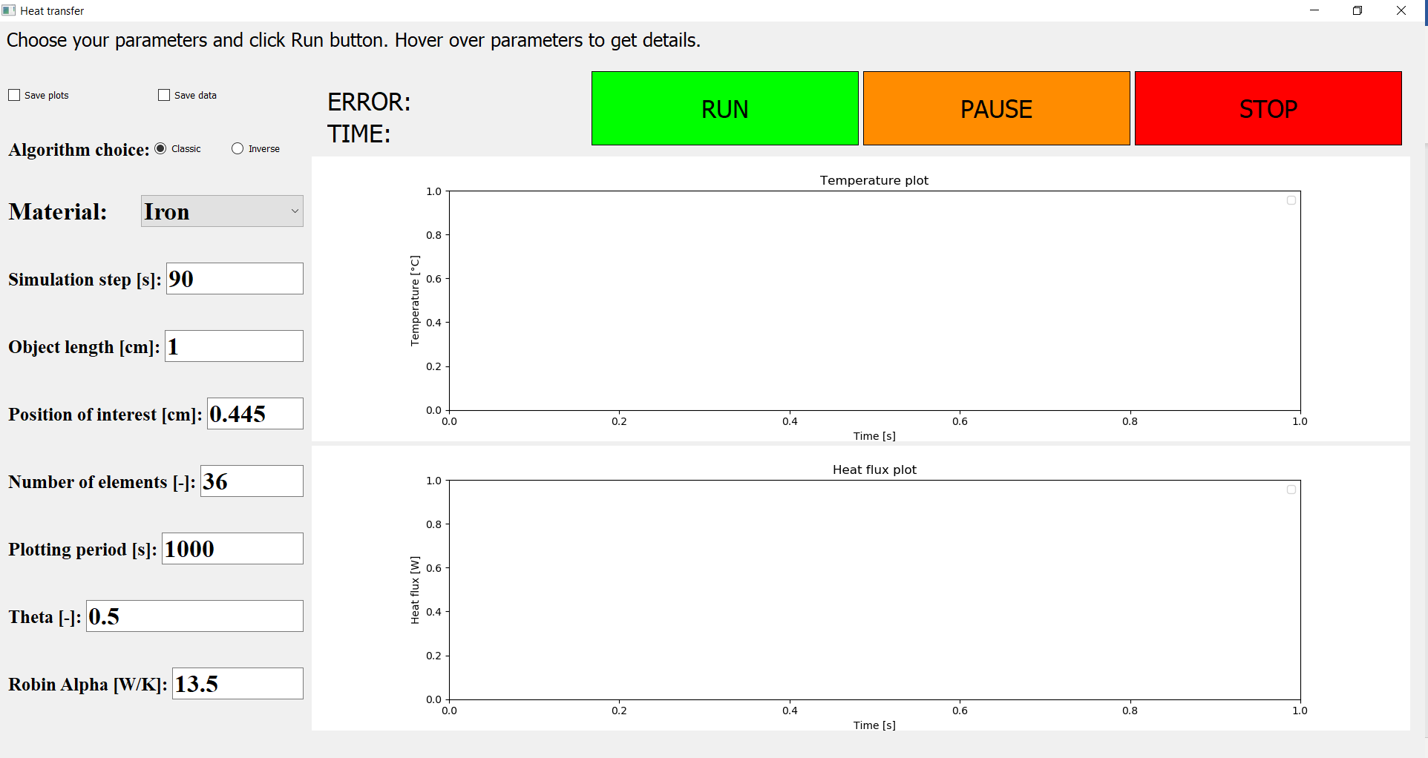 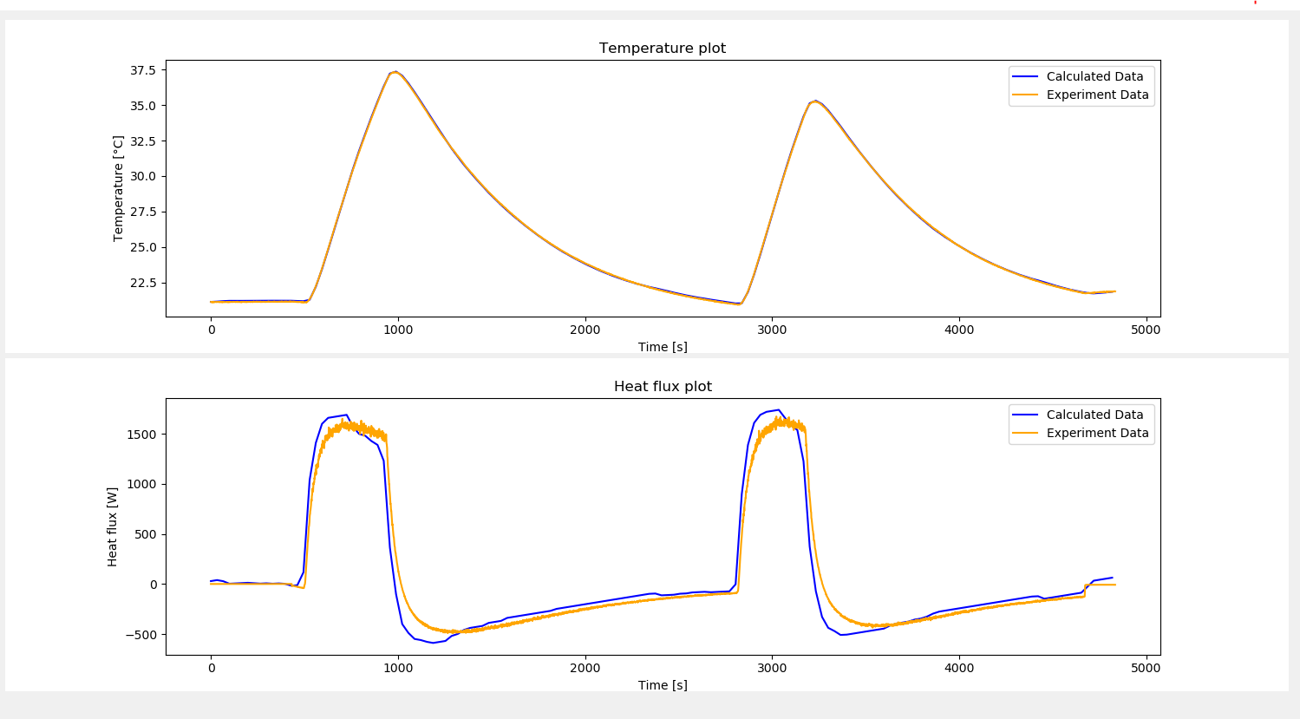

* Before launching the program
  + File with data names DATA.csv must be placed in the same directory as the .exe program.
  + It must contain comma-separated rows with measurement data regarding:
    - Time from the beginning of measurement [seconds]
    - Temperature measured inside the body [Celsius]
    - Heat flux applied to the body [Watt]
    - Ambient Temperature in the room [Celsius]
  + First line is reserved for the header, and is therefore skipped
* After launching the program
  + On the very top, there is always a short informational message, describing the current state of the application.
  + The whole left side is dedicated for users to specify their preferences.
    - Checkboxes on the top offer saving the results after the simulation – both the plots in .png format, and the calculated data in .csv format.
    - Below users can choose the algorithm they want from the radio button group (meaning only one button can be checked). “Classic” algorithm means we will be determining the temperatures in the body from the knowledge of heat fluxes. “Inverse” algorithm, on the other hand, means we will be trying to estimate the heat fluxes from the knowledge of the temperature.
      * The word “estimate” is there for a reason, instead of the word “determine”, because of the nature of the inverse problems – see the Inverse Problems chapter
    - Below the choice of algorithm users can choose the material from a dropdown menu. The menu consists of all metals, and each material has its own properties, that the calculation will be run with (rho, cp, lambda)
      * Users will also have a choice of defining their own materials, with their custom properties
    - Finally, there is a long list of numerical parameters that users can influence, that in turn influences the simulation. Hovering over the parameter name will show a short description of the parameter.
      * Inverse algorithm is taking two more parameters than the classic one – window span and tolerance.
      * The exhaustive list of all parameters with their description can be found in the Parameters inputted from user chapter
  + Buttons on top are responsible for controlling the simulation – starting it, pausing it or stopping it. When the button is active, it will be highlighted by a thick black margin around the edges.
  + Two labels between the buttons and input parameters are showing the time the simulation is in progress, as well as the final error after the simulation finishes.
  + The main elements on the screen are two graphs, which the results will be plotted into. The upper graph is responsible for showing temperature data, the bottom one shows heat flux values.
  + After the inverse simulation finishes
    - There is a possibility of smoothing the results appearing in the left menu

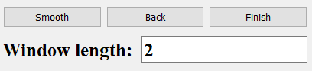

* + - We are smoothing the results by calculating average value of x nearby points around each point and assigning this as a new value for that specific point. By this we are getting rid of extremes and make the whole graph look smoother.
    - The window length is freely customizable, any integer can be inputted. Generally lower numbers are fitting when the simulation step (dt) was high. When we conducted simulation with a small dt (like 1 second), there is a lot of points on the graph, therefore also the window length should be higher to achieve the desired smoothing effect.
    - There is a possibility of reverting the previous state by clicking “Back” – we store all the past results, so user can freely experiment with different window lengths and then come to the very beginning.
    - Clicking “Finish” will accept the current situation of the heat flux, finish the simulation and calculate its error.

# Possible features and improvements

* Storing user preferences
* Storing history of all user simulations
* Making the calculation and graph plotting separate, so calculating thread is not slowed down by plotting
  + It would require some architectural changes
  + One way would be for calculation thread to output results to a file, where they would be discovered and processed by the plotting thread

# Parameters inputted from user

* + - **Simulation step**
      * Defines a time value for one simulation step – on how big time intervals will we cut the whole timeframe of the measurements.
      * **Assumption**: The larger this step, the quicker the simulation will be. However, the precision goes down with its increase.
      * Can be arbitrary decimal value (float)
      * Is expressed in seconds
    - **Object length**
      * Defines the length of the 1D object we are creating the simulation for
      * Can be arbitrary decimal value (float)
      * Is expressed in centimetres
    - **Position of interest**
      * Defines the distance from the beginning of the element in place in which the temperatures were measured
      * Can be arbitrary decimal value (float)
      * Is expressed in centimetres
      * Possible improvement: always check if this value is not higher than the Object length, as it would make no sense – and notify user about this
    - **Number of elements**
      * Defines how granular will the simulation grid be (how many nodes will be evenly placed on the whole Object length)
      * **Assumption**: The higher the number of elements, the more precise the calculation should be in theory. However, this will increase the simulation time, and the simulation error is not always going down paradoxically.
      * It can be arbitrary positive whole number, and has no units
    - **Plotting period**
      * Defines how frequently to update the plot, in the sense of simulation seconds
      * **Assumption**: Higher values will cause the simulation to be quicker, because the plotting does not have to occur so often, so less time will be spent on this
      * Can be arbitrary positive whole number
      * Is expressed in seconds
    - **Theta**
      * Determines explicitness (0) and implicitness (1) of the algorithm approach.
      * LINK SOME LINK HERE :) – for a resource where this is described
      * Explicitness means we are more focusing on matching already calculated values rather than on matching the future values from the measurement
      * Optimal values is 0.5
        + By 0.5, it produces error of 0,464
        + It crashes by 0.4
        + 0.6 = 0,463
        + 0.99 = 0,459
        + With the increase we can observe slight decrease of the error margin
        + VALUES UNDER 0,5 ARE CAUSING ERRORS

Probably there is a bug that is preventing us from doing that somehow

INVESTIGATE TO BE ABLE TO COMPARE THE APPROACHES

* + - * Can be arbitrary decimal value (float) between 0 and 1 and has no units
      * theta = 0.0 - fully explicit 1st order, numerically unstable.
      * theta = 0.5 - midpoint (Crank-Nicolson) 2nd order, numerically stable (probably the best choice).
      * theta = 1.0 - fully implicit 1st order, numerically stable.
      * When the simulation is explicit, there could be only a small error at the beginning, and it will be gradually increasing the magnitude (exponentially), and will cause the whole simulation to be worthless
  + There needs to be a small time_step dt, otherwise the solution will go out of control
  + There is a special value of dt, which it cannot exceed
    - Include some SOURCES here
    - **Robin Alpha**
      * Defines the convection heat transfer coefficient on the end of the object
      * Can be arbitrary decimal (float) number
      * Is expressed in Watt/Kelvin
    - **Window span**
      * Only for inverse simulation
      * Defines how far into the future to look when matching the temperatures during inverse simulation.
      * **Assumption**: Increasing the value will cause the simulation to take longer but has no big positive impact on the precision. On the contrary, we were getting the best results when the window span was only 1.
        + One disadvantage of having the window span as the smallest value of 1 is that it makes a lot of sharp spikes in heat fluxes – as it is only interested in one window at a time, and so reacts sharply on any change.
        + The window span of 2 has shown to be a nice compromise, as the precision is not so much smaller (error margin of 83 vs 76 by window span of 1) – and the heat fluxes were much smoother in time, with no drastic movements
      * It can be arbitrary positive whole number, and has no units
    - **Tolerance**
      * Only for inverse simulation
      * Defines how accurate should the temperature-matching be
      * **Assumption**: Higher values will cause the simulation to take longer time
      * Can be arbitrary decimal value (float) and has no units

# PARAMETERS TESTING

In order to have better understanding of all parameters that can vary in the simulation, it can be a good idea to find out how changing these parameters influences the final result. Namely, how do the simulation time and simulation error change when we play with the parameters.

parameters = {

"rho": 7850,

"cp": 520,

"lmbd": 50,

"dt": 10,

"object_length": 0.01,

"place_of_interest": 0.0045,

"number_of_elements": 100,

"callback_period": 500,

"robin_alpha": 13.5,

"theta": 0.5,

"window_span": 4,

"tolerance": 1e-05,

"q_init": 0,

"init_q_adjustment": 20,

"adjusting_value": -0.7

} … the default parameters

Hardware used for testing:

* Laptop Acer Aspire E5-575G, processor Intel® Core™ i5-6200U @ 2.30 GHz, 8GB RAM, 64bitový operační systém

Our goal was to find out which variable parameters will cause the results to be the best (the simulation being the quickest or the most precise).

There is a slight issue with just trying the simulation once with all the possible parameters, and that is the variable speed of CPU, which makes spotting small differences almost impossible. Therefore, it is beneficial to perform all the simulations multiple times and average out all the values afterwards. The more simulations we will do, the more precise should the average be, but it will also take longer time.

Tests were carried out on a laptop, and also on a Virtual Private Server. Running them on a server has the advantage of less other running processes. These running processes could increase the volatility of the results and make it less valuable.

## Methodology of the tests:

* It would certainly be possible to run all the tests by hand, manually inputting the changing parameters we want to test, and recording the resulting simulation time and error.
* However, this process would be very tedious, time consuming and prone to mistakes. Also, there is a direct correlation between the number of tests and the quality of the result, as it is usually much better to obtain multiple values and then average them out, instead of relying just on one value, that can be hindered by a mistake of whatever character.
* Therefore, a whole **testing framework** was developed to improve the speed and the quality of the tests, increase the reproducibility of the results, and offer quick visualisation and feedback.
  + Testing framework has the form of multiple python scripts. They are responsible for defining the parameters and their values we want to test, for running the tests themselves and for evaluating and visualizing the results.
  + All what is needed to use it is to define all possible values of a certain parameter. Simulation will be run with all these values and the results will be saved into a file and also into a graph.
  + We can also choose the number of times the tests will be run – the higher the number, the more stable the results should be, as the average of more tests is more precise than only one test alone. However, with the higher number of tests the overall time will also increase in a linear fashion.
  + There are multiple possibilities how to **define the list of values**, and each of those is best in a specific situation:
    - Manually creating the list
      * values = [1, 2, 3, 4, 5]
      * This way can be efficient when there is a small number of values or we want to choose only specific values, that are not easy to define programmatically
    - Using standard python
      * values = range(start=1, stop=6, step=1)
      * This is the most basic definition of a range of numbers – start at 1, continue until we are lower than 6, and take steps of 1. It creates a range of natural numbers from 1 to 5.
      * It has the disadvantage that it can operate only with integers (whole numbers), and does not support floats (decimal numbers), which is often needed
      * <https://pynative.com/python-range-function/>
    - Using numpy library
      * Numpy offers multiple functions to define a sequence of number values, and each of them has its unique use
      * numpy.linspace(start=1, stop=50, num=100)
        + “Return evenly spaced numbers over a specified interval”
        + We can specify how many numbers we want to get inside the interval – and these numbers will have the same (linear) space between them.
        + Our example returns 100 decimal numbers in the interval from 1 to 50
        + <https://docs.scipy.org/doc/numpy-1.10.0/reference/generated/numpy.linspace.html>
      * numpy.logspace(start=-5, stop=-1, num=100, base=10)
        + “Return numbers spaced evenly on a log scale”
        + Works the same as numpy.linspace(), but operates on a logarithmic scale – all numbers inside that interval have the same distance between each other from the logarithmic point of view, not from the linear (numerical) point of view
        + This example is returning with 100 numbers in interval from 10-5 to 10-1, which are gradually increasing their numerical distance between each other as they grow
        + This is extremely helpful when we want to evenly span interval containing multiple orders, as that from 10-5 to 10-1, because classical linear spacing would cause the majority of generated numbers being close to the higher value (in this case almost all numbers would be between 10-2 to 10-1, which is not desirable)
        + <https://docs.scipy.org/doc/numpy-1.10.0/reference/generated/numpy.logspace.html>
      * numpy.arange(start=0.5, stop=1, step=0.01)
        + “Return evenly spaced values within a given interval”
        + Behaves the same way as classical range() function, but is also working for decimal numbers (floats), which makes it ideal for generating intervals e.g. between 0 and 1
        + <https://docs.scipy.org/doc/numpy-1.10.0/reference/generated/numpy.arange.html>

## Results of the parameter testing:

* **Classic problems**
  + **Number of elements**

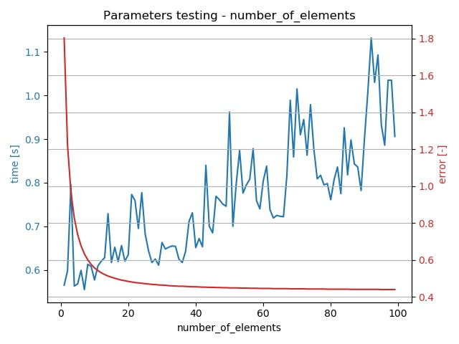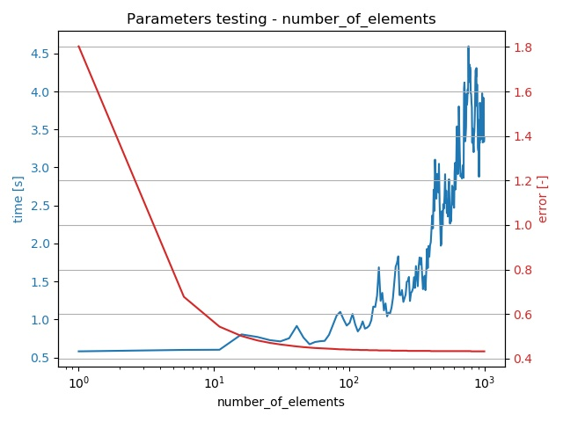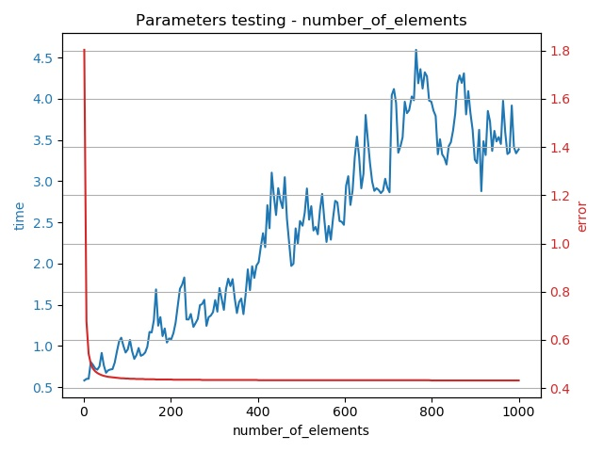

* + - We see that with increasing number of elements in our grid the simulation time is increasing in approximately linear fashion. The error margin is decreasing sharply in the beginning and seems to decrease in a slow manner even afterwards.
    - These effects are caused by the fact that the more elements are in the grid, the more calculations need to be done. More elements also better reflect the real conditions, when the number of elements is much higher.
    - It would be nice to observe the interval of the sharp error decrease (1-20 elements) to identify what is the least number of elements that yield a good result. Also, the other interval (20-1000) is worth exploring, as it can show whether the error is really decreasing even in higher number of elements.
    - The optimal number of elements seems to lie around **20-40 elements**, where the error margin has already decreased sharply, and the simulation time has not risen so much yet.
    - With the computer analysis of the smallest product of simulation time and error margin, we found out that the optimal number of elements is **36.**
    - **Discussion**: The length of the whole object must be also taken into account to generalize the recommendation of using the certain number of elements. Longer objects will need to be divided into more elements than shorter objects. Probably it could be worth to give the recommendation using not element number, but the size of one element (object 1 cm long divided into 20 elements = **0.5 mm per one element**). However, this value can be highly depending on the material that is used in the experiment – completely different results could have been yielded when we would use a wooden object instead of a steel one.
  + **Dt**
    - 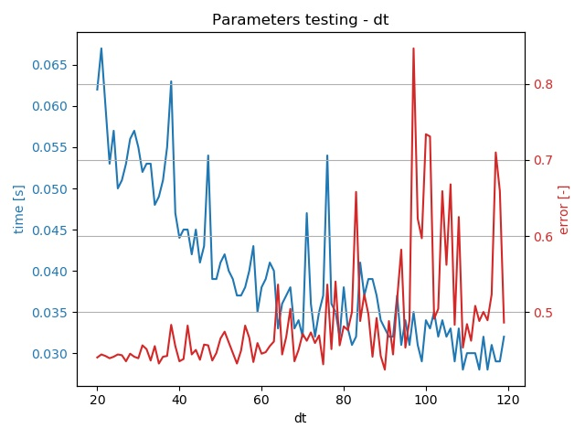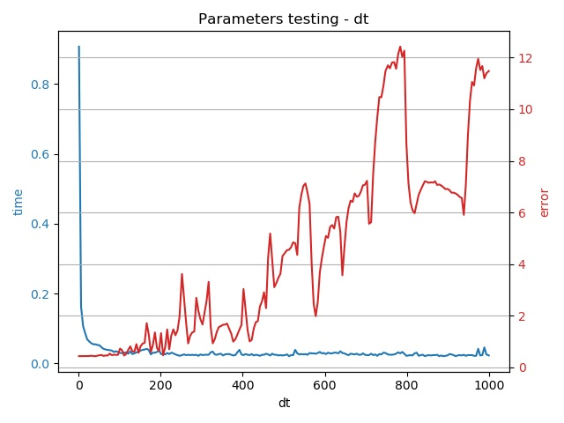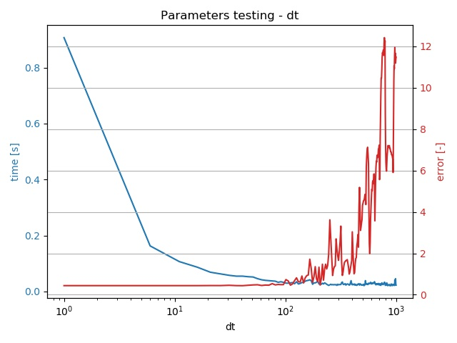It is apparent that with the increasing dt (timestep) the error is also increasing. Simulation time, on the other hand, is going down.
    - Reason for this behaviour is that with the higher values of dt there is less steps in the simulation to be calculated, therefore it takes less time for the simulation to finish.
    - With the higher dt we are also taking bigger steps at a time, which means we are neglecting what happened between those bigger intervals. This fact is causing the error margin to increase, because less information is taken into account, and this uncertainty is responsible for the error.
    - Sharp rises and falls in error margin between 600 and 1000 can be worth exploring – the probable explanation is that some of these timesteps are missing the rises or falls of the experiment heat flux, so they are less accurate than others.
    - Optimal number of steps seems to be around **40-60**, which is high enough for the simulation time to be low, and also low enough for the error not to be so high.
    - Computer analysis showed that the optimal value of dt is **90**.
    - **Discussion**: The recommended time step in seconds is very specific to this experiment. To illustrate the point, we simply cannot choose a time step of 50 seconds when the experiment took only 30 seconds in total. Therefore, a better recommendation can be to calculate the number of steps in the whole experiment. In this case it would be 4500 seconds and 50 seconds for one step = **90 steps in total**. However, every experiment is different, and it can happen that there is a lot of sudden spikes in the heat-flux, which would not be taken into account if the time step was bigger.
  + **Theta**

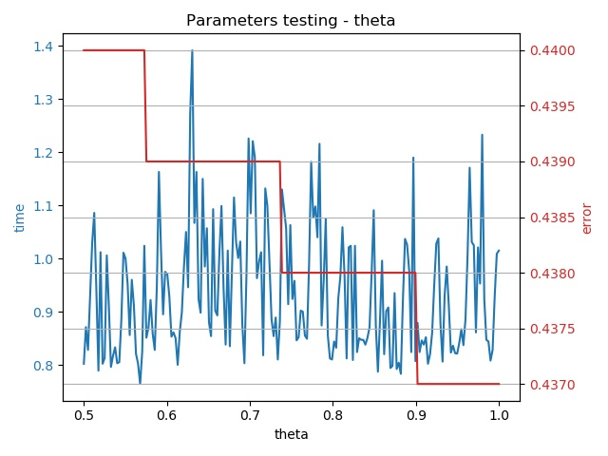

* + - The increase in theta is followed by a very small decrease in error. (The error value is decreasing consistently with increasing theta – however, because of rounding the error on 3 decimals, it creates this diagram reminding steps) The time does not look like being dependant on theta at all.
* **Inverse problems**
  + 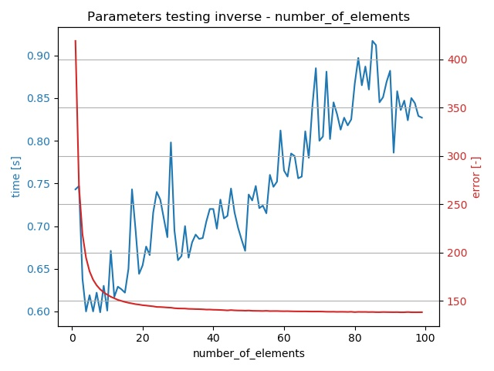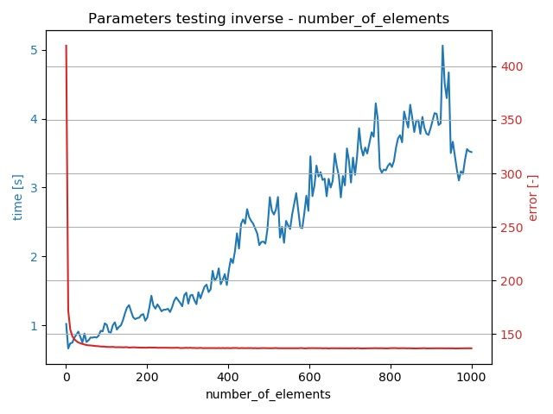**Number of elements**
    - Here we can observe the same dependence of both simulation time and error to the number of elements as in the classical problem.
    - **Discussion**: The optimal number of elements seem to lie around **40-60**.
    - Computer analysis showed that the optimal value is **15**.
  + 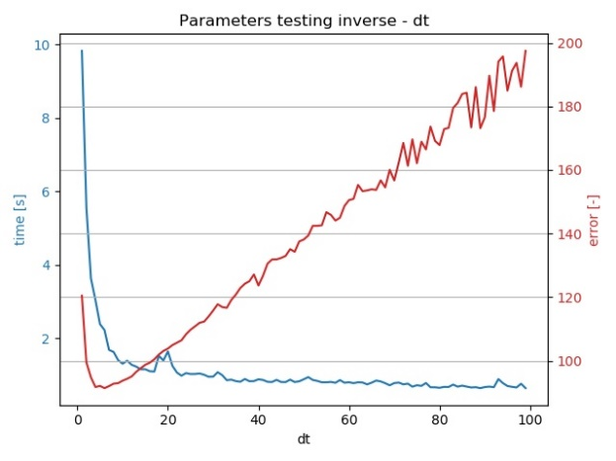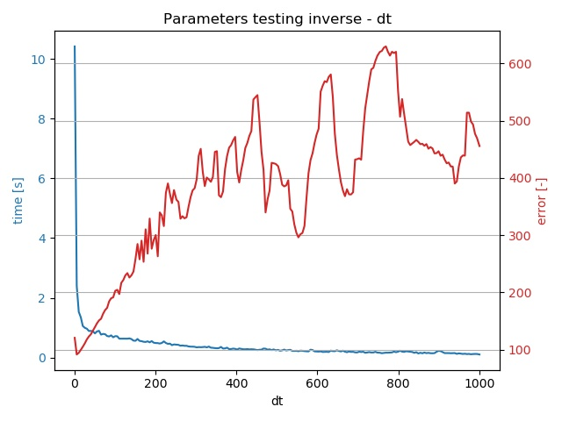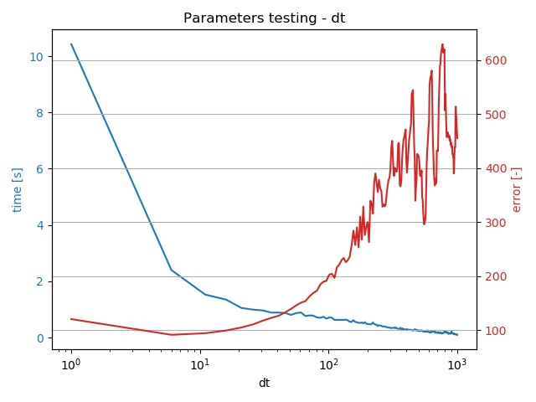**Dt**
    - The same general behaviour as in classical problem can be seen here – higher time steps result in higher error and lower simulation time.
    - What differs, however, is the rate in which the error margin is increasing at the very beginning. Because of this rapid increase in error margin, it seems that increasing time step just to speed the simulation up a little bit makes no sense.
    - **Discussion**: Therefore, we can recommend the time step being lower than in classical problems, around **20**. It should be also mentioned that the very smallest values of time step (1-5) are causing the heat flux plot looking very badly, with a lot of sharp edges.
    - According to computer calculations, the optimal value lies at **33**.
  + **Theta**

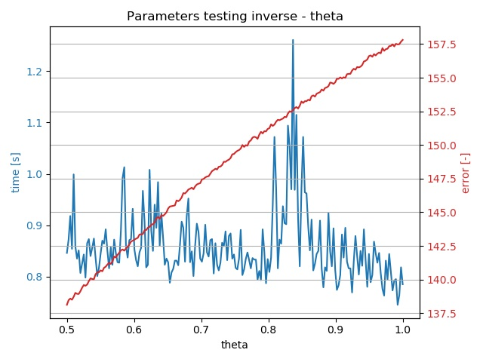

* + - In contrast with classical problems, where nothing seemed to depend on theta so much, here in inverse problem, we see an apparent correlation in error margin – it goes up with increasing theta.
    - Simulation time seems to be quite unpredictable, but its minimal values are going down with increase in theta.
    - **Discussion**: Because with increasing theta the time is generally getting better and error is getting worse, it is hard to recommend the optimal value of theta. However, because the error is rising consistently and time is fluctuating a lot, it could be worth recommending the smallest theta possible here – **0.5**.
  + **Window span**

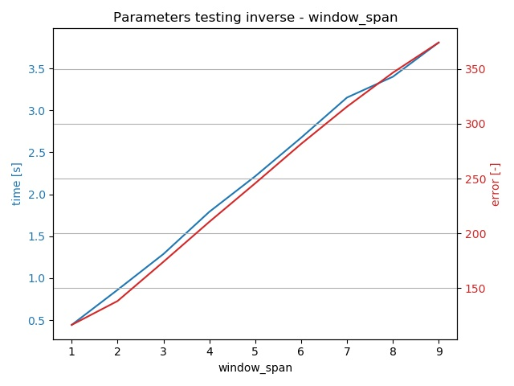

* + - Very interesting and seemingly counterintuitive situation can be found here – with the increase of window span we see both the simulation time and error margin to rise. Also, interestingly, they are rising almost at the very same, linear pace.
    - Explaining the rising simulation time seems easy – if we need to match more windows into the future, it will take longer.
    - It is not straightforward to reason the increase in error margin. It could be explained by “overfitting” (<https://en.wikipedia.org/wiki/Overfitting>) – we were creating a heat flux profile that was matching lot of windows to the future, but this involved creating unnecessarily complex functions that were spoiling the overall result. (??? - VERIFY)
    - **Discussion**: There seems to be an easy conclusion, that it is not worth increasing the window span, and that the recommended value is **1**.

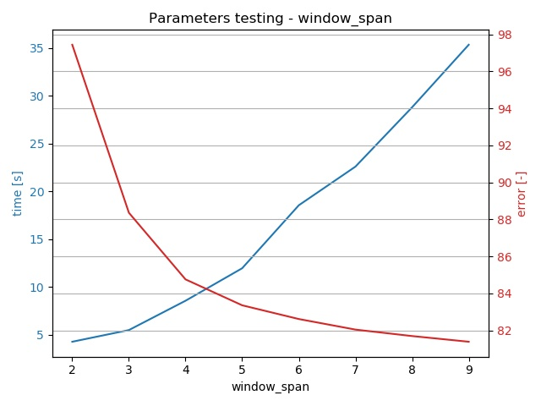

* + - The abovementioned behaviour was found very strange, so we were encouraged to review the logic for inverse simulation, and thanks to it we discovered a bug inside.
      * Even when we chose higher window span than 2, we were modifying the heat flux values only for two first windows, and others were unassigned, which was causing the error to be higher with the rising window span.
    - After changes the dependence looked already more realistic – with the higher window span the error was decreasing. However, the simulation time went rapidly up.
  + **Tolerance**

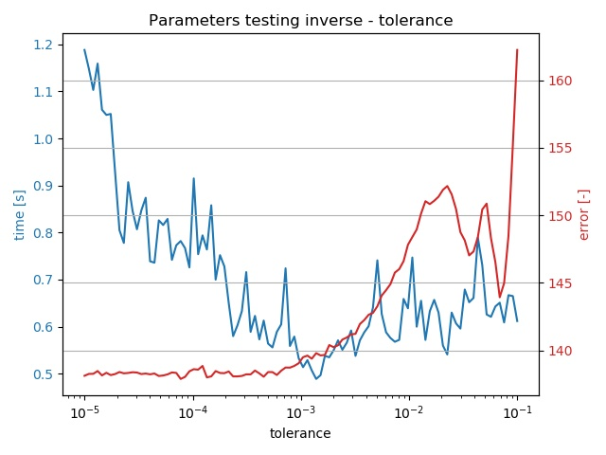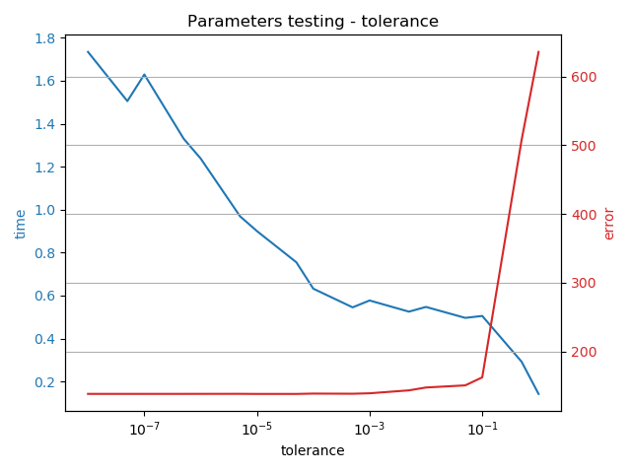

* + - Beware that the graph has a logarithmic x-axis, because the values range from 1e-8 to 1
    - When changing tolerance, we can observe two straightforward trends – the increase causes the error margin to rise, and the simulation time to fall.
    - This is caused by needing less calculation when the tolerance of the matching is higher – it causes the simulation to be quicker. On the other hand, the result becomes less precise, therefore the error margin keeps increasing.
    - **Discussion**: It seems reasonable to search for the optimal point somewhere **between 1e-4 and 1e-2**, because the error margin has not yet started rising dramatically, and the time is not decreasing so much anymore.
    - According to computer, the optimal spot lies at **0.0014.**
  + Adjusting value

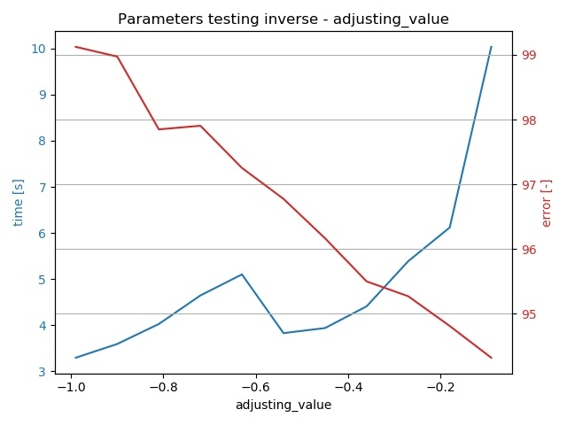

* + - TODO: create more thorough tests and describe it + describe adjusting value as argument
  + TODO: Create tests and description for the q_init and other new arguments
* TESTING OBSERVATIONS:
  + The lower dt, the less amount of iterations is needed
    - Meaning we probably do not need any special methods for determining the good heatflux (like bisection method), when we have a very low dt
    - Explanation can be that the difference in heat fluxes for a shorter time is lower, therefore we can reach the next value quicker
    - Also it is good to decrease the init_q_adjustment with decreasing dt, because the changes in heatflux for that shorter time period is expected to be lower
  + Smoothing the data helps reducing errors in some situations (best way from 85 to 65)
    - TODO: describe the process of smoothing, and its challenges
    - Moving average is turning out to be better
    - It can be advantageous to perform the smoothing multiple times
    - 2 times 2 window length yields the best results when dt is 20
* Theoretically we could automate the determination of the optimal point by searching for a point that yields the lowest result of multiplying time by error (as we want both values to be as low as possible). Because we have all the data from graphs available in a file, it is very easy to do. (However, in this case we should also disregard cases when the simulation is maybe lightning quick but yields spoiled results.)
  + It was done by parameters_testing_optimum_finding.py
  + We just specify the json file with results, and it will analyse all the tested parameters and return the values that yield the smallest product of multiplying simulation time by the error margin
  + However, it is debatable, if the approach of just multiplying time by error is the best comparison, and the error should not be accounted for more. We can paraphrase the saying that “The good feeling from a good price is quickly gone, but the bad feeling from a bad quality still persists” to say that “The immediate satisfaction with quick results is not lasting long, but the superior and more precise results are long lasting.”
* It should be also pointed out that there the word “optimal” is subjective here – every experiment can be different, some require higher level of precision, no matter what the time cost is, others are not so crucial, and some precision can be sacrificed to speed the simulation up to yield quick results.
* What can be also important, is the graphical representation of the result – in the case of higher dt (simulation step) for example, the graph does not look very smooth, as the space between the steps is filled with a linear dependency (a straight line). Therefore, it could be more desirable to rather decrease the value of dt just from this reason.
* Logarithmic axes could be used to visualise the results better, when showing very diverse data

# TODOS AND IDEAS

* Allow for theta less than 0.5, which is currently not possible
  + It is possible, but the errors at the end of the simulation are going balististic
  + With step 1 second even with theta 0.498 it is going crazy after 4000 second
* Allow users to specify the location of data file – do not have the requirement of DATA.csv
  + When the software will be used “in production”, there will be no need for the heat flux column, as it will be our goal to determine it, without knowing it
* Allow for custom user material
* Incorporate metals_properties.csv into the .exe build
  + If not possible, have it as a python module
* Convert the application to PySide2 instead of PyQt5 at the very end
* Create a .py file from .ui file at the very end
* Contemplate the visualising of Parameters testing
* Create a diagram of all software components
  + Maybe also a diagram of the functions in the computational engine
* Test the impact of q_init in inverse problems – and probably make it inputable from GUI
* Test the impact of the coefficient q_adj is being multiplied by (-0.7 now)
* Test the impact of the whole inverse approach (changing window span, q_init, having various logic for finding satisfying heat flux etc.) on more data sources
  + We can even randomly generate some heat flux values in time, calculate the temperature distribution through our NumericalForward, and then trying NumericalInverse for these temperature data, generating heat flux values again and comparing them with the original heat flux values
  + This way we could test all the approaches more thoroughly, because so far, we can test it only on one specific simulation, which is not a very representative sample
* Fix the filename of the DATA.csv to always have absolute path, for the data file not having to be inside the same directory as our program